CHINESE FLAGSHIP SECONDARY CURRICULUM
Chinese II, Unit 4, Home and Community
Interpretive Reading Assessments
Learning targets:
1. Students can write simple directions to get somewhere.
2. Students can write a description of their home or their community.

Presentational Writing Assessment 1

Scenario: You just come back from China after being an exchange student for a year there. Your friend just got approved to be an exchange student this year. S/he asks you for directions on how to get to his school from the airport. Please draw a simple map from the airport to your school in China and write down the directions and how to get there by any means of transportation.

Presentational Writing Assessment 2
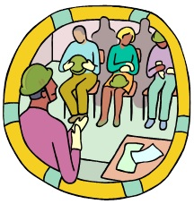
Scenario: Your Chinese teacher would like to know about your neighborhood. She asks you to make a poster about your neighborhood and to introduce it in a written form.
· Narrate the place you live and some major stores nearby your house;
· Mention how far these places are from your home; and
· Where the places are located relative to each other
· Describe the methods of transportation you use to get to each one;

Adapted from Jefferson County Public Schools, KY, 2011

